## Arrays- Quiz 03

**Predict the output of the code given below?**

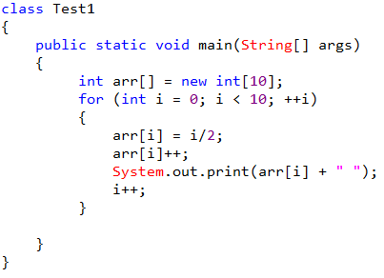

Choose only ONE best answer.

**A**

Error

**B**

1 2 3 4 5

**C**

1 2 3 4 5 6 7 8 9

**D**

2 4 6 8

**The correct answer is 'B'**In the above code array object is created which stores 10 elements For i = 0: arr[0] = 0/2 = 0 , arr[i] value is incremented by 1 thus arr[0] = 1, i value is incremented to 1in the next step. In the for loop i value gets incremented again thus i value is 2 : arr[2] = 2/2 = 1, arr[i] value is incremented by 1 thus arr[2] = 2, i value is incremented to 1 in the next step. In the for loop i value gets incremented again thus i value is 4 : arr[2] = 4/2 = 2, arr[i] value is incremented by 1 thus arr[2] = 3, i value is incremented to 1in the next step. This continues until the condition fails thus output is 1 2 3 4 5

**Predict the output of the code?**

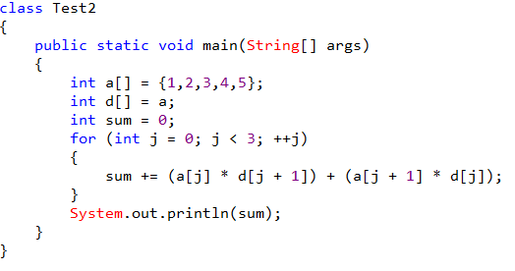

Choose only ONE best answer.

**A**

28

**B**

40

**C**

35

**D**

38

Ans : B

a and d both the arrays are equal. For loops range from 0 to 2 = 0 + (1 * 2) + (2 * 1) = 4. For j = 0:  sum = 0 + (a[0] * d[0 + 1]) + (a[0 + 1] * d[0]) .For j= 1: sum = 4 + (a[1] * d [2]) + (a[2] * d[1]) = 4 + 6 + 6 = 16. For j = 2: sum = 16 + (a[2] * d[3]) + (a[3] * d[3]) = 16 + (3 * 4) + (4 * 3) = 40. Thus the output of the code is 40.

**What is the output of the code given below?**

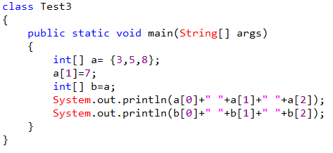

Choose only ONE best answer.

**A**

3 7 8 3 7 8

**B**

3 5 8 3 7 8

**C**

3 7 8 3 5 8

**D**

Error

**The correct answer is 'A'**

**Predict the output of the code?**

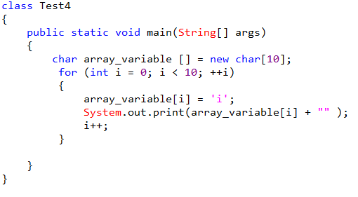

Choose only ONE best answer.

**A**

1 2 3 4 5

**B**

i i i i i

**C**

iiiii

**D**

12345

Ans: iiiii

i iterates from 0 to 9: i = 0: array_variable[0] = ‘i’, i value is incremented in the next step and i value is again incremented in for loop thus finally i value is 2 , i = 2: array_variable[0] = ‘i’, i value is incremented in the next step and i value is again incremented in for loop thus finally i value is 4, loop continues to iterates and thus the output is iiiii

**Predict the output of the code?**

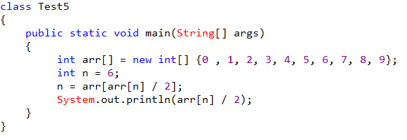

Choose only ONE best answer.

**A**

1

**B**

3

**C**

6

**D**

2

**This answer is incorrect. The correct answer is 'A'**n = 6, n = arr[arr[n] / 2] = arr[arr[6]/2] = arr[6/2] = arr[3] arr[3]/2 = 1 thus the output is 1

**Predict the output of the code?**

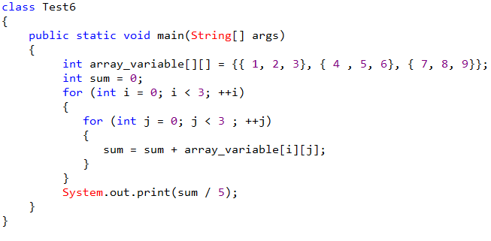

Choose only ONE best answer.

**A**

Error

**B**

9

**C**

6

**D**

3

**The correct answer is 'B'**i = 0, j = 0: sum = 0 + 1 = 1 i = 0, j = 1: sum = 1 + 2 = 3 i = 0, j = 2: sum = 3 + 3 = 6 i = 1, j = 0: sum = 6 + 4 = 10 i = 1, j = 1: sum = 10 + 5 = 15 i = 1, j = 2: sum = 15 + 6 = 21 i = 2, j = 0: sum = 21 + 7 = 28 i = 2, j = 1: sum = 28 + 8 = 36 i = 2, j = 2: sum = 36 + 9 = 45 sum/5 = 45/5 = 9

**Predict the output of the code?**

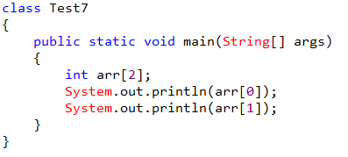

Choose only ONE best answer.

**A**

0 0

**B**

Garbage Value

**C**

Error

**D**

None of the abov

**The correct answer is 'C'**

**Predict the output of the code?**

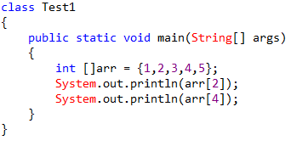

Choose only ONE best answer.

**A**

3 5

**B**

2 4

**C**

3 6

**D**

None of the above

**The correct answer is 'A'**

**Predict the output of the code?**

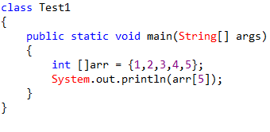

Choose only ONE best answer.

**A**

4

**B**

5

**C**

ArraysIndexOutOfBoundsException

**D**

None of the above

**Ans: C**

In the above code we are accessing the elements which is out of the range so you are getting exception.

**In general, the index of the first element in an array is __________.**

Choose only ONE best answer.

**A**

0

**B**

-1

**C**

2

**D**

1

**The correct answer is 'A'**